Lab 08 - Manage Virtual Machines

Student lab manual

Objectives

In this lab, you will:

* Task 1: Deploy zone-resilient Azure virtual machines by using the Azure portal and an Azure Resource Manager template
* Task 2: Configure Azure virtual machines by using virtual machine extensions
* Task 3: Scale compute and storage for Azure virtual machines
* Task 4: Register the Microsoft.Insights and Microsoft.AlertsManagement resource providers
* Task 5: Deploy zone-resilient Azure virtual machine scale sets by using the Azure portal
* Task 6: Configure Azure virtual machine scale sets by using virtual machine extensions
* Task 7: Scale compute and storage for Azure virtual machine scale sets (optional)

## Task 1: Deploy zone-resilient Azure virtual machines by using the Azure portal and an Azure Resource Manager template

* 1. Sign in to the Azure portal.
  2. In the Azure portal, search for and select Virtual machines and, on the Virtual machines blade, click + Create, click + Azure virtual machine.

* 1. On the Basics tab of the Create a virtual machine blade, specify the following settings (leave others with their default values):

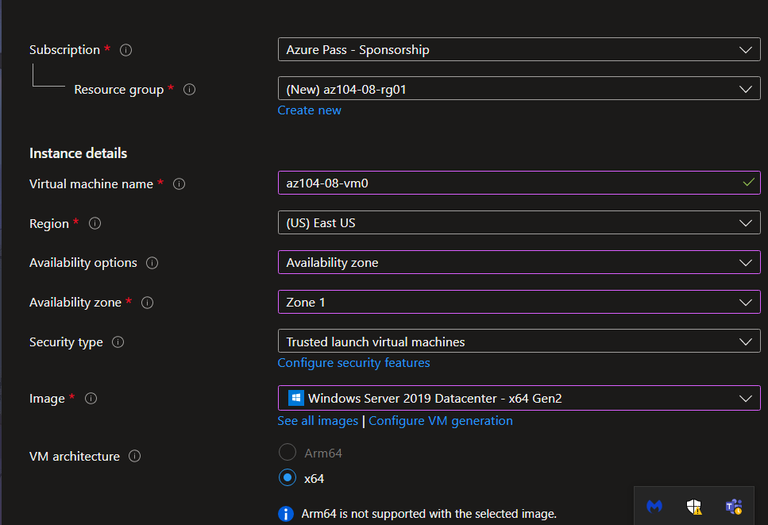

* 1. Click Next: Disks > and, on the Disks tab of the Create a virtual machine blade, specify the following settings (leave others with their default values):

* 1. Click Next: Networking > and, on the Networking tab of the Create a virtual machine blade, click Create new below the Virtual network textbox.

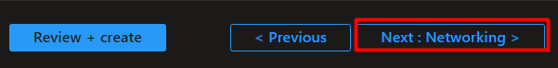



* 1. On the Create virtual network blade, specify the following settings (leave others with their default values):

* 1. Click OK and, back on the Networking tab of the Create a virtual machine blade, specify the following settings (leave others with their default values):

* 1. Click Next: Management > and, on the Management tab of the Create a virtual machine blade, specify the following settings (leave others with their default values):

* 1. Click Next: Monitoring > and, on the Monitoring tab of the Create a virtual machine blade, specify the following settings (leave others with their default values):

* 1. Click Next: Advanced >, on the Advanced tab of the Create a virtual machine blade, review the available settings without modifying any of them, and click Review + Create.

* 1. On the Review + Create blade, click Create.

* 1. On the deployment blade, click Template.

* 1. Review the template representing the deployment in progress and click Deploy.

* 1. On the Custom deployment blade, specify the following settings (leave others with their default values):

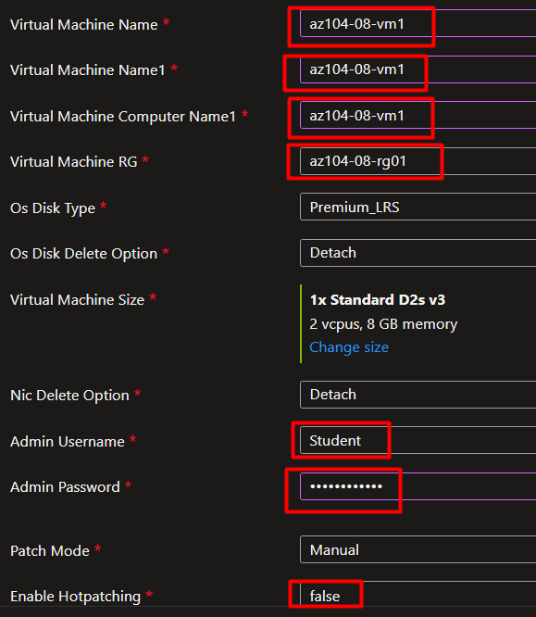

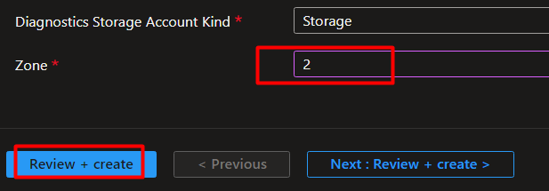

* 1. Click Review + Create, on the Review + Create blade, click Create.

## Task 2: Configure Azure virtual machines by using virtual machine extensions

1. In the Azure portal, search for and select Storage accounts and, on the Storage accounts blade, click the entry representing the diagnostics storage account you created in the previous task.

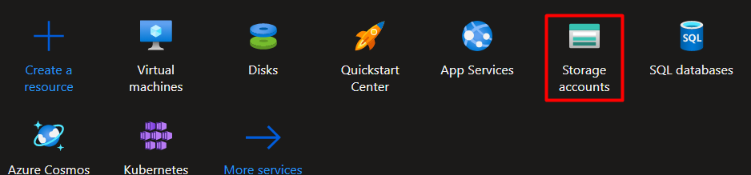

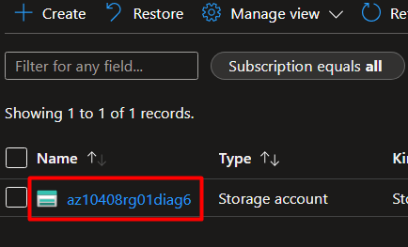

1. On the storage account blade, in the Data Storage section, click Containers and then click + Container.

* This step is in the screenshot in the next step.

1. On the New container blade, specify the following settings (leave others with their default values) and click Create.

1. Back on the storage account blade displaying the list of containers, click scripts.

1. On the scripts blade, click Upload.

1. On the Upload blob blade, click the folder icon, in the Open dialog box, navigate to the \Allfiles\Labs\08 folder, select az104-08-install_IIS.ps1, click Open, and back on the Upload blob blade, click Upload.

1. In the Azure portal, search for and select Virtual machines and, on the Virtual machines blade, click az104-08-vm0.

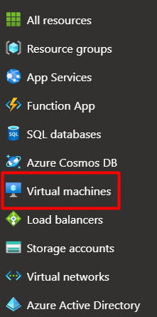

1. On the az104-08-vm0 virtual machine blade, in the Settings section, click Extensions + applications, and the click + Add.

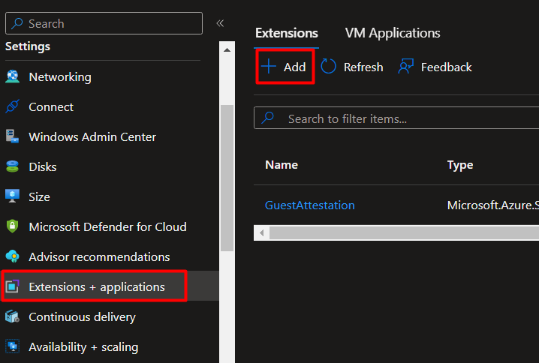

1. On the Install an Extension blade, click Custom Script Extension and then click Next.

1. From the Configure Custom Script Extension Extension blade, click Browse.

1. On the Storage accounts blade, click the name of the storage account into which you uploaded the az104-08-install_IIS.ps1 script, on the Containers blade, click scripts, on the scripts blade, click az104-08-install_IIS.ps1, and then click Select.

1. Back on the Install extension blade, click Review + create and, on the Review + create blade click Create.

1. In the Azure portal, search for and select Virtual machines and, on the Virtual machines blade, click az104-08-vm1.

1. On the az104-08-vm1 blade, in the Automation section, click Export template.

* This step is in the screenshot in the next step.

1. On the az104-08-vm1 - Export template blade, click Deploy.

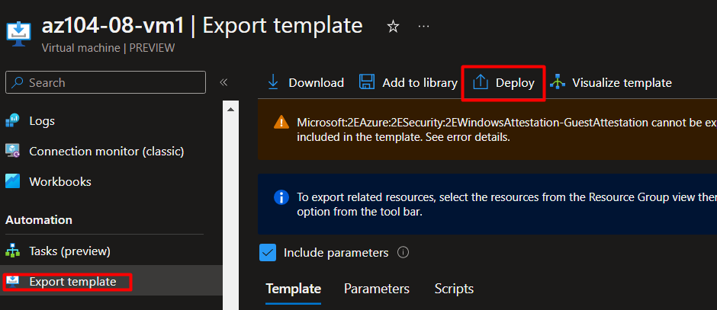

1. On the Custom deployment blade, click Edit template.

1. On the Edit template blade, in the section displaying the content of the template, insert the following code starting with line 20 (directly underneath the "resources": [ line):

1. Click Save and, back on the Custom template blade, click Review + Create and, on the Review + Create blade, click Create.

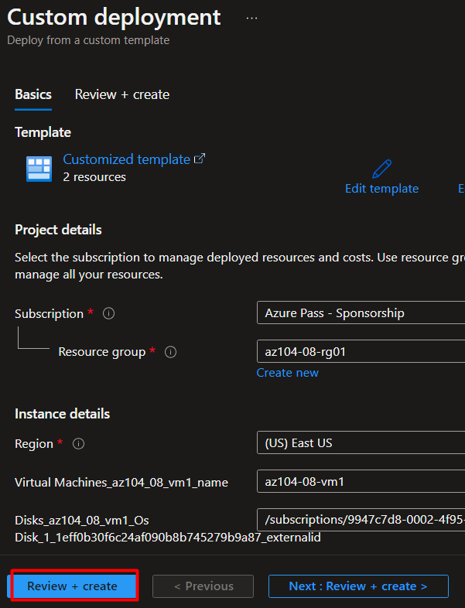

1. To verify that the Custom Script extension-based configuration was successful, navigate back on the az104-08-vm1 blade, in the Operations section, click Run command, and, in the list of commands, click RunPowerShellScript.

1. On the Run Command Script blade, type the following and click Run to access the web site hosted on az104-08-vm0.

## Task 3: Scale compute and storage for Azure virtual machines

1. In the Azure portal, search for and select Virtual machines and, on the Virtual machines blade, click az104-08-vm0.

1. On the az104-08-vm0 virtual machine blade, click Size and set the virtual machine size to Standard DS1_v2 and click Resize.

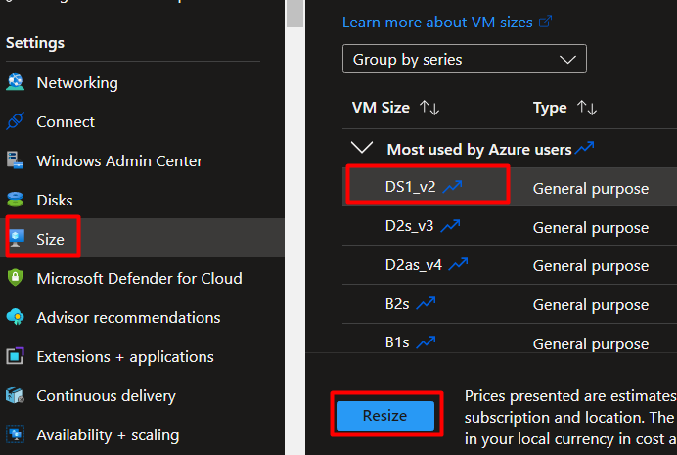

1. On the az104-08-vm0 virtual machine blade, click Disks, Under Data disks click + Create and attach a new disk.
2. Create a managed disk with the following settings (leave others with their default values):
3. Back on the az104-08-vm0 - Disks blade, Under Data disks click + Create and attach a new disk.
4. Create a managed disk with the following settings (leave others with their default values) and Save changes:
5. Back on the az104-08-vm0 - Disks blade, click Save.

* Because from task 3 to task 7 we needed to create and attach a new disks I made one screenshot for the tasks above.

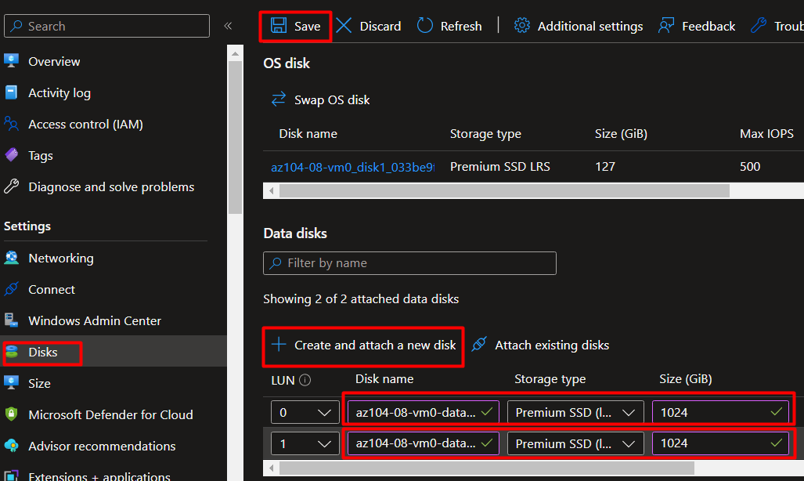

1. On the az104-08-vm0 blade, in the Operations section, click Run command, and, in the list of commands, click RunPowerShellScript.

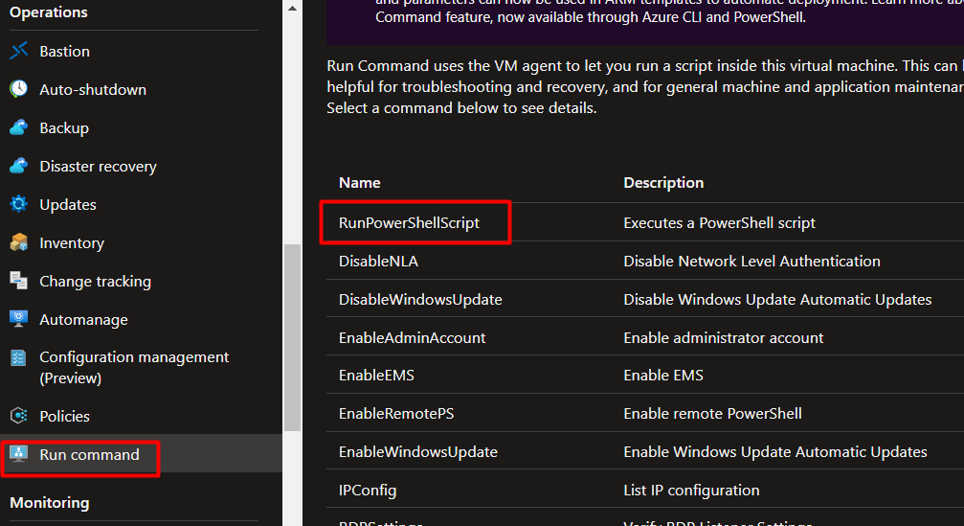

1. On the Run Command Script blade, type the following and click Run to create a drive Z: consisting of the two newly attached disks with the simple layout and fixed provisioning:

* We needed to execute the following shell script:

New-StoragePool -FriendlyName storagepool1 -StorageSubsystemFriendlyName "Windows Storage*" -PhysicalDisks (Get-PhysicalDisk -CanPool $true)

New-VirtualDisk -StoragePoolFriendlyName storagepool1 -FriendlyName virtualdisk1 -Size 2046GB -ResiliencySettingName Simple -ProvisioningType Fixed

Initialize-Disk -VirtualDisk (Get-VirtualDisk -FriendlyName virtualdisk1)

New-Partition -DiskNumber 4 -UseMaximumSize -DriveLetter Z

And the output of the script is in the screenshot.

1. In the Azure portal, search for and select Virtual machines and, on the Virtual machines blade, click az104-08-vm1.
2. On the az104-08-vm1 blade, in the Automation section, click Export template.
3. On the az104-08-vm1 - Export template blade, click Deploy.

1. On the Custom deployment blade, click Edit template.
2. On the Edit template blade, in the section displaying the content of the template, replace the line 30 "vmSize": "Standard_D2s_v3" with the following line):

1. On the Edit template blade, in the section displaying the content of the template, replace line ("dataDisks": [ ] line) with the following code :

1. Click Save and, back on the Custom deployment blade, click Review + Create and, on the Review + Create blade, click Create.

* After we saved the template we went back in the Custom deployment blade and we reviewed the template. As a feedback we got validation passed and we can now create it.

1. Back on the az104-08-vm1 blade, in the Operations section, click Run command, and, in the list of commands, click RunPowerShellScript.
2. On the Run Command Script blade, type the following and click Run to create a drive Z: consisting of the two newly attached disks with the simple layout and fixed provisioning:

* To create drive Z we needed to execute the following script command, and the output of the command in the screenshot:

New-StoragePool -FriendlyName storagepool1 -StorageSubsystemFriendlyName "Windows Storage*" -PhysicalDisks (Get-PhysicalDisk -CanPool $true)

New-VirtualDisk -StoragePoolFriendlyName storagepool1 -FriendlyName virtualdisk1 -Size 2046GB -ResiliencySettingName Simple -ProvisioningType Fixed

Initialize-Disk -VirtualDisk (Get-VirtualDisk -FriendlyName virtualdisk1)

New-Partition -DiskNumber 4 -UseMaximumSize -DriveLetter Z

(Due to its , somewhat big output, I have just the first part of the script output)

## Task 4: Register the Microsoft.Insights and Microsoft.AlertsManagement resource providers

1. In the Azure portal, open the Azure Cloud Shell by clicking on the icon in the top right of the Azure Portal.
2. If prompted to select either Bash or PowerShell, select PowerShell.
3. From the Cloud Shell pane, run the following to register the Microsoft.Insights and Microsoft.AlertsManagement resource providers.

* In this task we needed to register the Microsoft.Insights and Microsoft.AlertsManagement resource providers by running the 2 scripts in the Azure cloud shell.
* Microsoft.Insights and Microsoft.AlertsManagement are part of Azure Monitor services that help with performance and availability of the applications and services.

## Task 5: Deploy zone-resilient Azure virtual machine scale sets by using the Azure portal

1. In the Azure portal, search for and select Virtual machine scale sets and, on the Virtual machine scale sets blade, click + Add (or + Create).
2. On the Basics tab of the Create a virtual machine scale set blade, specify the following settings (leave others with their default values) and click Next : Disks >:

1. On the Disks tab of the Create a virtual machine scale set blade, accept the default values and click Next : Networking >.
2. On the Networking tab of the Create a virtual machine scale set blade, click the Create virtual network link below the Virtual network textbox and create a new virtual network with the following settings (leave others with their default values):

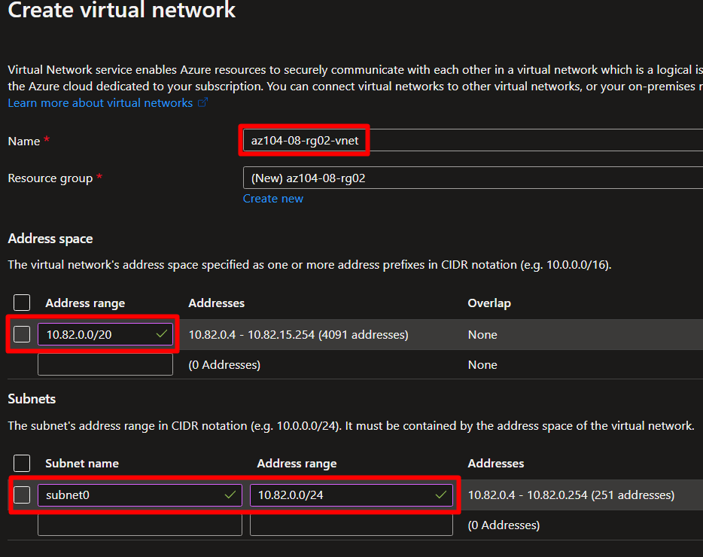

1. Back on the Networking tab of the Create a virtual machine scale set blade, click the Edit network interface icon to the right of the network interface entry.

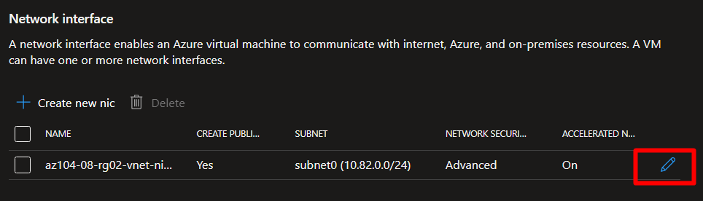

1. On the Edit network interface blade, in the NIC network security group section, click Advanced and click Create new under the Configure network security group drop-down list.

1. On the Create network security group blade, specify the following settings (leave others with their default values):
2. Click Add an inbound rule and add an inbound security rule with the following settings (leave others with their default values):
3. Click Add and, back on the Create network security group blade, click OK.

* Task 7 to task 8 are put into one screenshot.

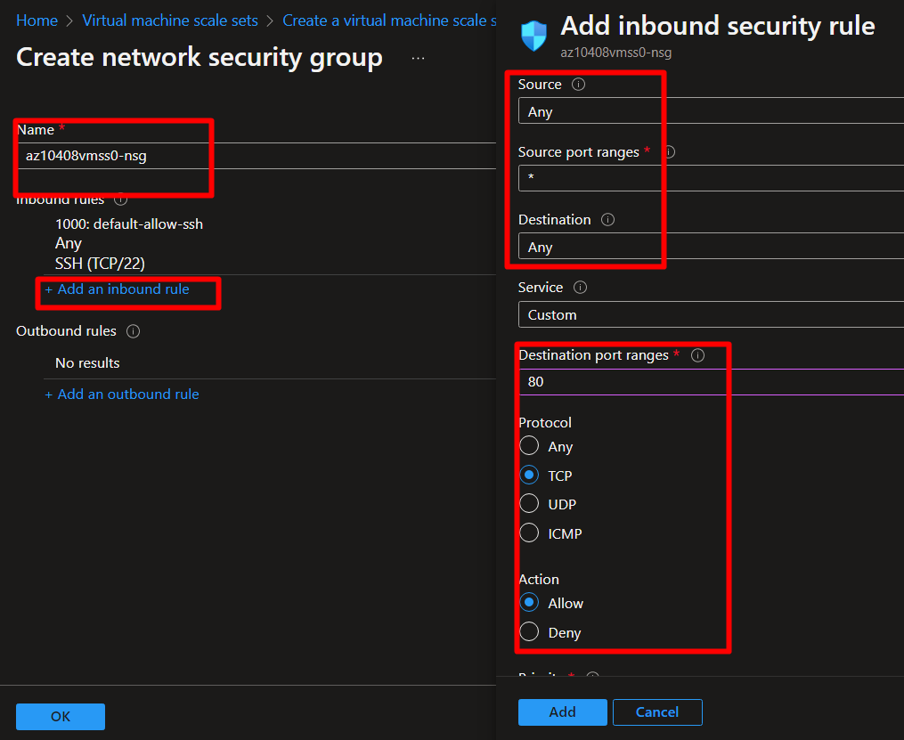

1. Back on the Edit network interface blade, in the Public IP address section, click Enabled and click OK.

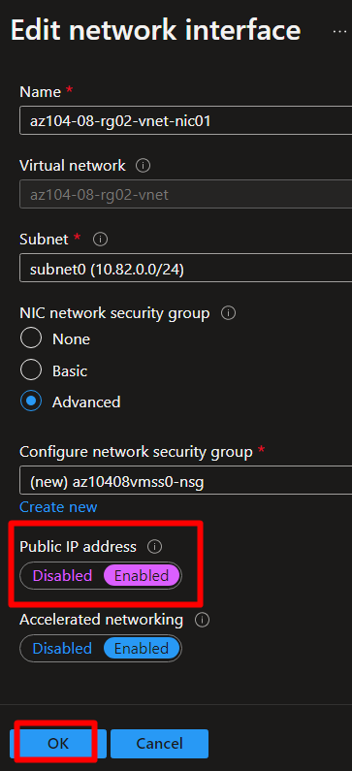

1. Back on the Networking tab of the Create a virtual machine scale set blade, under the Load balancing section, ensure that the Use a load balancer entry is selected and specify the following Load balancing settings (leave others with their default values) and click Next : Scaling >:
2. On the Scaling tab of the Create a virtual machine scale set blade, specify the following settings (leave others with their default values) and click Next : Management >:

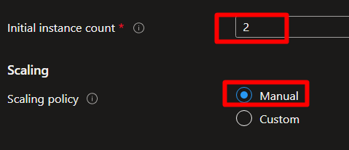

1. On the Management tab of the Create a virtual machine scale set blade, specify the following settings (leave others with their default values):

1. On the Health tab of the Create a virtual machine scale set blade, review the default settings without making any changes and click Next : Advanced >.
2. On the Advanced tab of the Create a virtual machine scale set blade, specify the following settings (leave others with their default values) and click Review + create.

1. On the Review + create tab of the Create a virtual machine scale set blade, ensure that the validation passed and click Create.

## Task 6: Configure Azure virtual machine scale sets by using virtual machine extensions

1. In the Azure portal, search for and select Storage accounts and, on the Storage accounts blade, click the entry representing the diagnostics storage account you created in the previous task.

* Here we select the storage account we created earlier.

1. On the storage account blade, in the Data Storage section, click Containers and then click + Container.
2. On the New container blade, specify the following settings (leave others with their default values) and click Create:

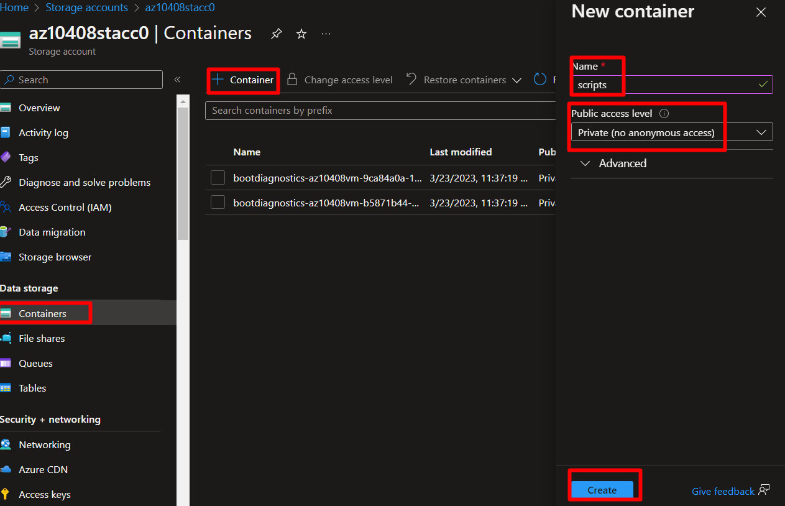

1. Back on the storage account blade displaying the list of containers, click scripts.
2. On the scripts blade, click Upload.
3. On the Upload blob blade, click the folder icon, in the Open dialog box, navigate to the \Allfiles\Labs\08 folder, select az104-08-install_IIS.ps1, click Open, and back on the Upload blob blade, click Upload.

* We upload the .ps1 file that is provided in the labs folder

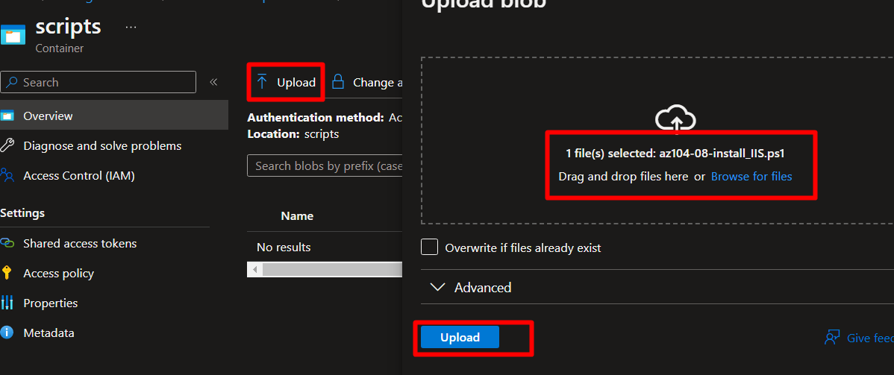

1. In the Azure portal, navigate back to the Virtual machine scale sets blade and click az10408vmss0.
2. On the az10408vmss0 blade, in the Settings section, click Extensions and applications, and the click + Add.

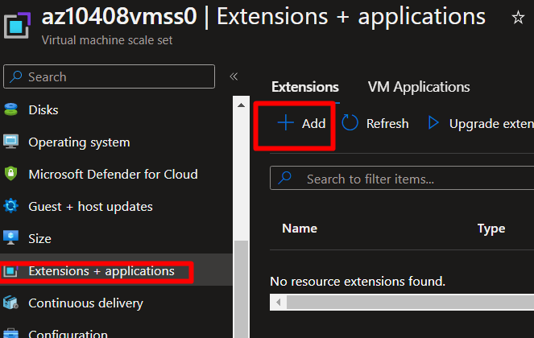

1. On the New resource blade, click Custom Script Extension and then click Next.
2. From the Install extension blade, Browse to and Select the az104-08-install_IIS.ps1 script that was uploaded to the scripts container in the storage account earlier in this task, and then click Create.

1. In the Settings section of the az10408vmss0 blade, click Instances, select the checkboxes next to the two instances of the virtual machine scale set, click Upgrade, and then, when prompted for confirmation, click Yes.

* After we click Yes we need to wait for the VM instances to upgrade.

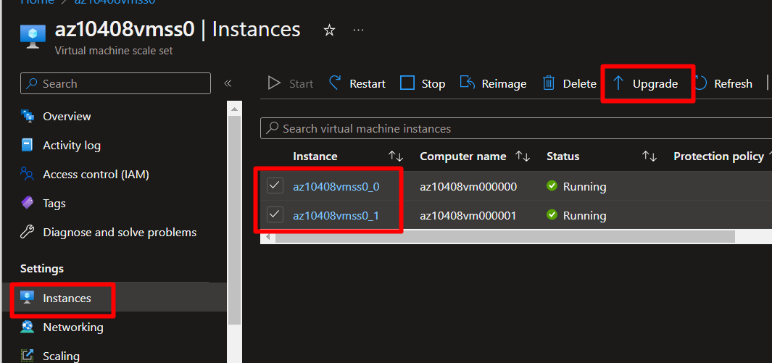

1. In the Azure portal, search for and select Load balancers and, in the list of load balancers, click az10408vmss0-lb.
2. On the az10408vmss0-lb blade, note the value of the Public IP address assigned to the frontend of the load balancer, open an new browser tab, and navigate to that IP address.

* When we navigate to the Public IP address that was assigned we indeed see one of the instances of the Azure virtual machine sale set az10408vmss0.

## Task 7: Scale compute and storage for Azure virtual machine scale sets

1. In the Azure portal, search for and select Virtual machine scale sets and select the az10408vmss0 scale set.
2. In the az10408vmss0 blade, in the Settings section, click Size.
3. In the list of available sizes, select Standard DS1_v2 and click Resize.
4. In the Settings section, click Instances, select the checkboxes next to the two instances of the virtual machine scale set, click Upgrade, and then, when prompted for confirmation, click Yes.
5. In the list of instances, click the entry representing the first instance and, on the scale set instance blade, note its Location (it should be one of the zones in the target Azure region into which you deployed the Azure virtual machine scale set).
6. Return to the az10408vmss0 - Instances blade, click the entry representing the second instance and, on the scale set instance blade, note its Location (it should be one of the other two zones in the target Azure region into which you deployed the Azure virtual machine scale set).
7. Return to the az10408vmss0 - Instances blade, and in the Settings section, click Scaling.
8. On the az10408vmss0 - Scaling blade, select the Custom autoscale option and configure autoscale with the following settings (leave others with their default values):
9. Click the + Add a rule link and, on the Scale rule blade, specify the following settings (leave others with their default values):
10. Click Add and, back on the az10408vmss0 - Scaling blade, specify the following settings (leave others with their default values):
11. Click Save.

* From task 1 to task 11 we:
  + Resized the **az10408vmss0** scale set with **Standard DS1_v2** size.
  + Upgraded the two instances form the virtual machine sale set:

**az10408vmss0_0** and **az10408vmss0_1.**

* + We checked the Location for the 2 instances separately:

**az10408vmss0_0** – is in Location UK South (Zone 1)

**az10408vmss0_1** – is in Location UK South (Zone 2)

* + We Scaled the **az10408vmss0** virtual machine scale set with **Scale mode** set to **Scale based on a metric**.
  + We also added **Scale rules**  and saved the changes.

1. In the Azure portal, open the Azure Cloud Shell by clicking on the icon in the top right of the Azure Portal.
2. If prompted to select either Bash or PowerShell, select PowerShell.
3. From the Cloud Shell pane, run the following to identify the public IP address of the load balancer in front of the Azure virtual machine scale set az10408vmss0.

The error message I received was due to wrong name for the IP address from the load balancer. When I corrected the name a did not receive an error message.



1. From the Cloud Shell pane, run the following to start an infinite loop that sends the HTTP requests to the web sites hosted on the instances of Azure virtual machine scale set az10408vmss0.

* After we execute the command:

while ($true) { Invoke-WebRequest -Uri "http://$pip" }

there Is an infinite loop. (Screenshot is just for reference for the loop).

1. Minimize the Cloud Shell pane but do not close it, switch back to the az10408vmss0 - Instances blade and monitor the number of instances.

* Now there is a third instance

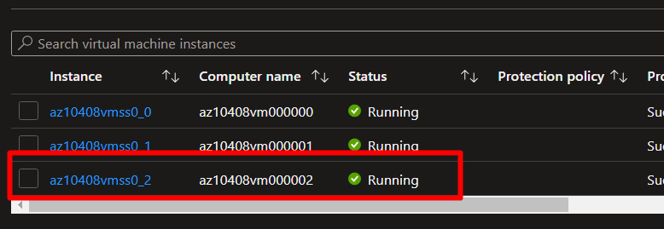

1. Once the third instance is provisioned, navigate to its blade to determine its Location (it should be different than the first two zones you identified earlier in this task.

It is in a different zone than the other 2.

1. Close Cloud Shell pane.
2. On the az10408vmss0 blade, in the Settings section, click Disks, click + Create and attach a new disk, and attach a new managed disk with the following settings (leave others with their default values):

1. Save the change, in the Settings section of the az10408vmss0 blade, click Instances, select the checkboxes next to the instances of the virtual machine scale set, click Upgrade, and then, when prompted for confirmation, click Yes.
2. In the Settings section of the az10408vmss0 blade, click Extensions and applications, click CustomScriptExtension, and then click Uninstall.
3. In the Azure portal, open the Azure Cloud Shell by clicking on the icon in the top right of the Azure Portal.
4. If prompted to select either Bash or PowerShell, select PowerShell.
5. In the toolbar of the Cloud Shell pane, click the Upload/Download files icon, in the drop-down menu, click Upload and upload the file \Allfiles\Labs\08\az104-08-configure_VMSS_disks.ps1 into the Cloud Shell home directory.
6. From the Cloud Shell pane, run the following to display the content of the script:

* After we uploaded the .ps1 file we ran the following commands:

Set-Location -Path $HOME

Get-Content -Path ./az104-08-configure_VMSS_disks.ps1

1. From the Cloud Shell pane, run the following to execute the script and configure disks of Azure virtual machine scale set:

* After running the ./az104-08-configure_VMSS_disks.ps1 (its just a portion form the output)

1. Close the Cloud Shell pane.
2. In the Settings section of the az10408vmss0 blade, click Instances, select the checkboxes next to the instances of the virtual machine scale set, click Upgrade, and then, when prompted for confirmation, click Yes.